Lab Report – Claudio Vestini

## Introduction

Over the past week, I have analysed the design and operation of a Francis Turbine. This inward-flow reaction turbine combines radial and axial flow concepts and was invented by James B. Francis in the 1850s.

This report will highlight meaningful data and findings obtained in this process.

## Design and Geometry

The part drawings provided allowed us to create SolidWorks models for each component and join them in a Solid Assembly. However, we noticed a problem with said assembly: since each crank was connected to the next via a rigid link through an eccentric linkage, every crank’s instantaneous centre of rotation was slightly offset from the next one’s, resulting in each guide vane being turned through a different radius in the mechanism.  
This was clear when plotting the distance (magnitude) between adjacent vanes: the first two vanes behaved differently from the last two at every handle operational point (fig1).

Figure 1 Default assembly vane distance plot

See the end of this document for technical drawings of all (default and not) parts [1].

Two approaches were implemented in trying to resolve this issue:

1. Create a solid large ring to guide every crank simultaneously. This approach revealed to be very energy-intensive, lengthy, and produced poor results (fig2): the vanes behaved as wanted for small handle angles, but diverged at high angles

Figure 2 Ring assembly vane distance plot

1. Place each crank at its fully open position, then manually measure the distance between the adjacent connection holes (equally spaced for all cranks due to symmetry) and create a new link geometry with holes spaced apart by the same distance. This was a much simpler approach, which also resulted in its being very successful. There was no notable difference between the guide vanes’ distances close to and far away from the handle (fig 3), so this new assembly was eventually selected as the final solution.

Figure 3 Finalised assembly vane distance plot

Figure 4 Modified link design

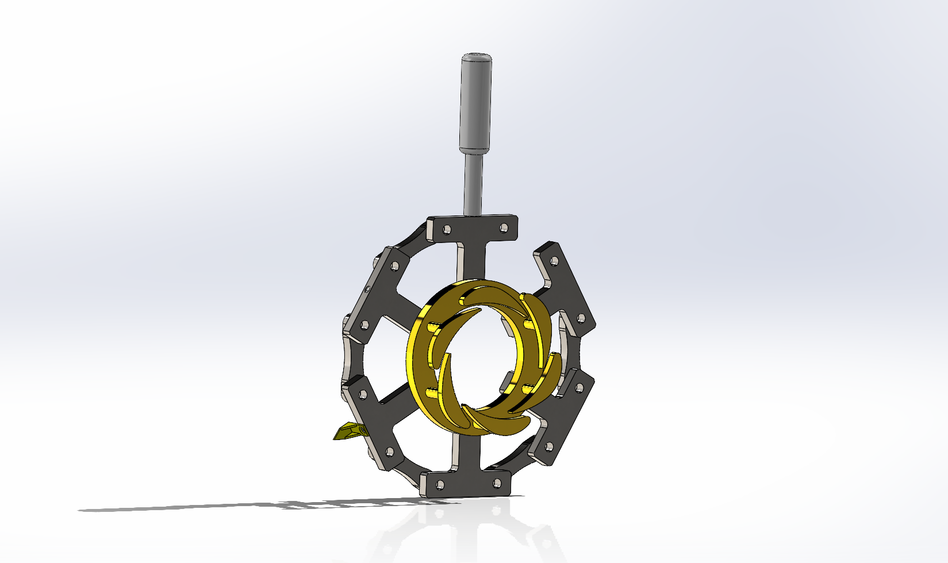

Figure 5 Final design for the guide vane assembly

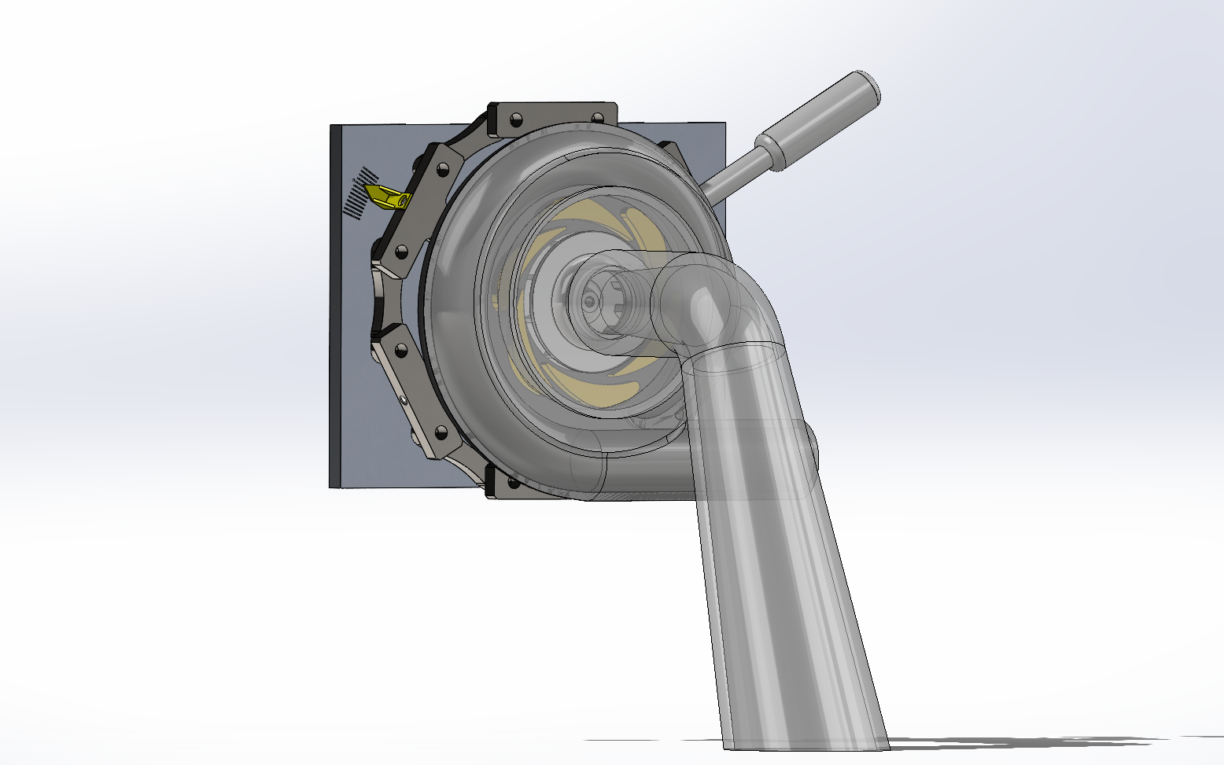

Figure 6 Finalised global assembly

## Experimental Results

After performing a hands-on experiment with the physical rig, we were able to graph the performance characteristics of the Francis turbine. The results showed that the peak efficiency is obtained at a flow rate of about 2 l/s at 70% opening (with a maximum efficiency of 23%).

Figure 7 Excel experimental data

Where the LHS column represents:

* Δp1 = pressure difference across the venturi, used to calculate flow rate
* p2 = gauge pressure at the inlet of the turbine, used to calculate W_th
* T = torque produced by rotating runner
* N = runner speed in units of revolutions per minute
* W_ts = power generated by the turbine
* GV% = percentage of opening of the guide vane angle
* Q_v = volumetric water flow rate
* W_th = head of water available at the turbine entry (in units of power)
* n_t = turbine efficiency

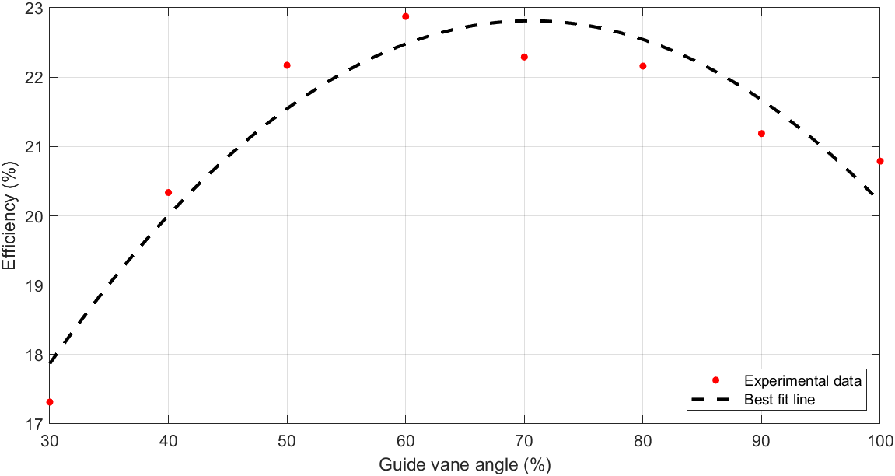

Figure 8 Efficiency vs Vane angle plot

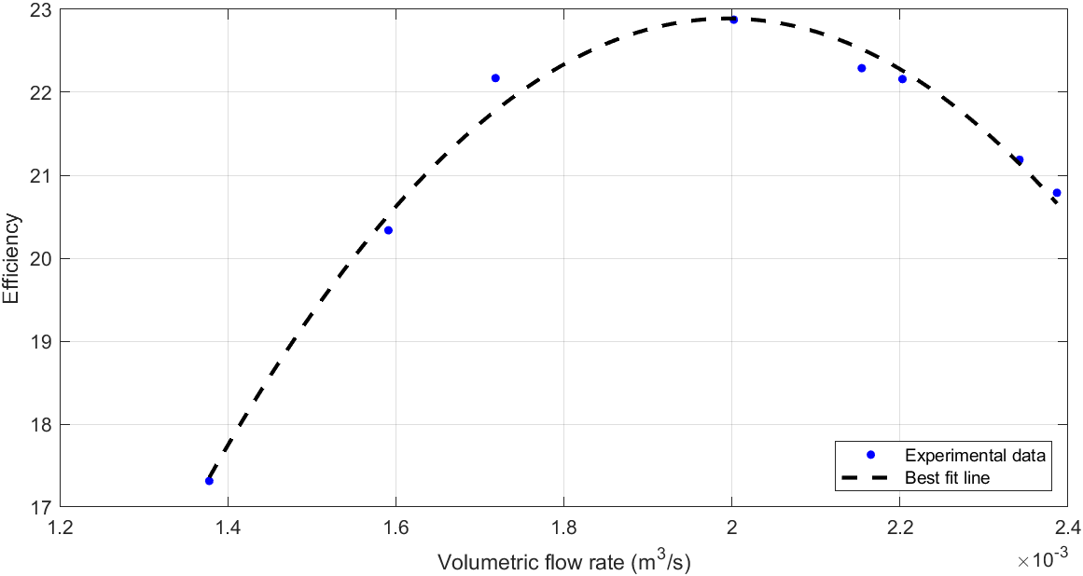

Figure 9 Efficiency vs flow rate plot

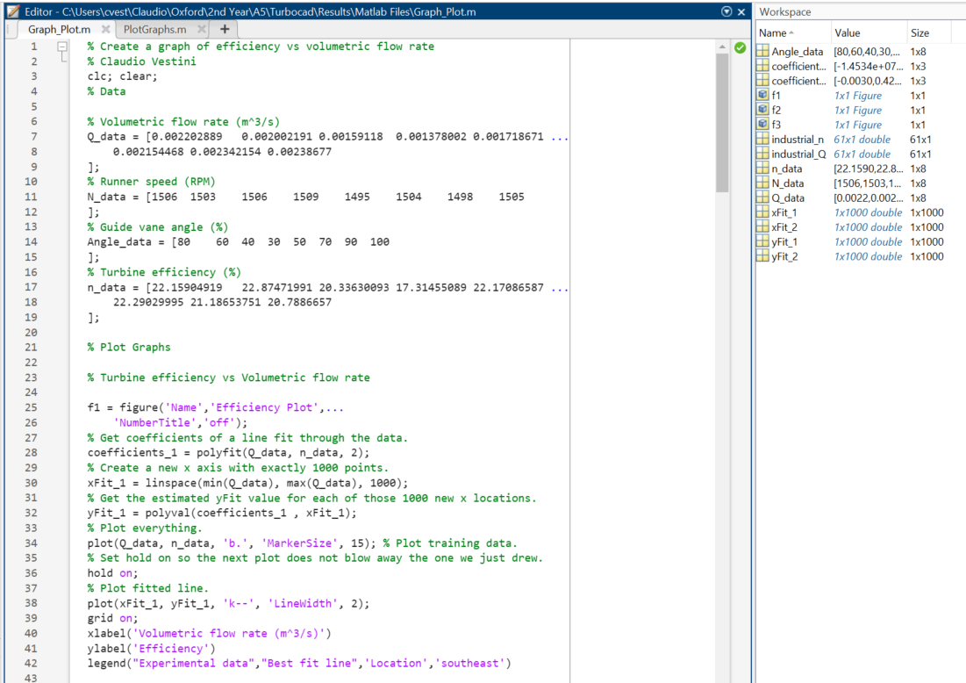

Figure 10 MATLAB script

## Comparison to industrial equipment

To complete the analysis, I compared the Thom building experimental results to some of the industry standard-level Francis turbines.

The results of this comparison showed how poor our maximum efficiency (23%) was in comparison to that achievable by some of the world-leading plants (which can get upwards of 95%). For the graph (fig11) I used this resource: [Francis Turbine Design on Malabar Mini Hydropower Plant*, R.P. Dewi,* *ResearchGate, 2018*.](https://ieeexplore.ieee.org/document/8739449)

Figure 11 Comparison of efficiency plots to industry standard

Some possible reasons behind this large gap in performance include:

* Leakage: there was constant spillage in the Thom building rig, which resulted in head loss across the system
* Size and scale: the Thom building turbine is very small in size. This means that boundary layers and viscous friction have much larger effects on the system efficiency. The best industrial turbines are much larger, which also permits them to turn the water flow by a larger angle in the axial direction. They generate more impulse as well as lift forces, which is why their efficiencies can be so high
* Pump-induced vorticity: we used a centrifugal pump as a “virtual reservoir”. This, however, is not entirely the same as having a physical reservoir to draw water from, as it introduces vorticity in the flow, and possibly makes flow cavitate as well

## Technical Drawings

**Drg No Title**

GV000 Guide Vane Mechanism Assembly - *Modified*

GV001 Guide Vane Crank

GV002 Handle

GV003A Guide Vane Link - *Modified*

GV004 Indicator

GV005 Guide Vane

GV006 Guide Vane Sealing Ring

TC000 Turbine Assembly - *Modified*

DT002 Draft Tube Reducer

RU001 Runner

VC001 Volute Casing Front

VC002 Volute Casing Rear

MP001 Mounting Plate

SP001 Sealing Plate

DS001 Drive Shaft

